**Team 6- Ryan Cranston, Petal Michaud, Julian Welge**

**Part 1 - PGP Basics**

* Original and decrypted message from Petal to Ryan

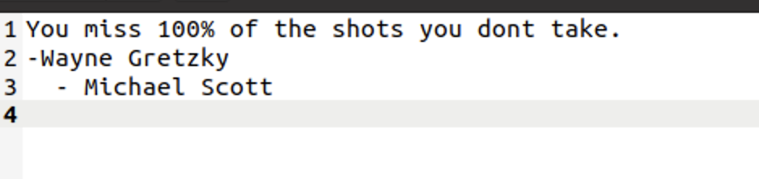

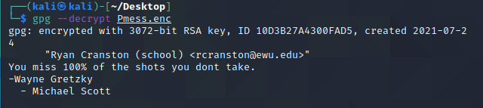

* Original and decrypted message from Petal to Julian

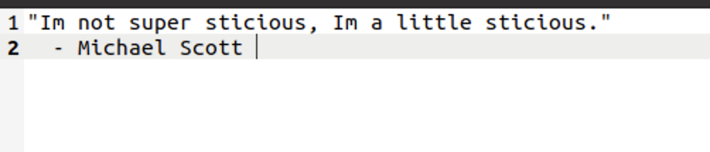

(missing decrypted message)

* Original and decrypted message from Ryan to Julian

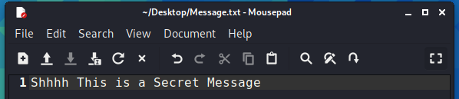

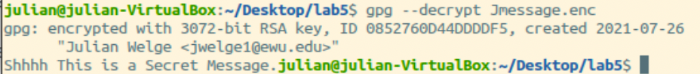

* Original and decrypted message from Ryan to Petal

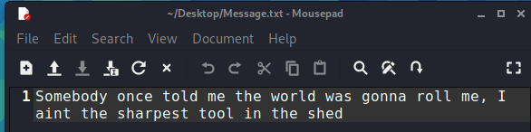

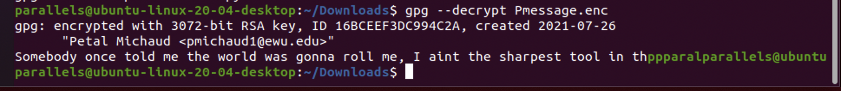

* Original and decrypted message from Julian to Ryan

(missing both)

* Original and decrypted message from Julian to Petal

(missing both)

**Part 2 - PGP Symmetric Mode**

* Password retrieved from encrypted file using Julian's private key

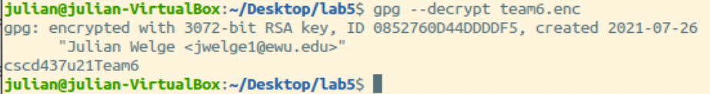

* Message retrieved from symmetrically encrypted file

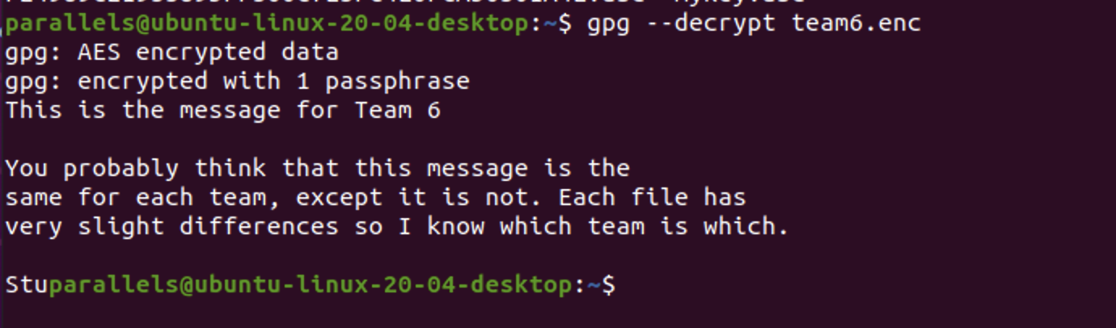

**Part 3 - Java Cryptography**

* Output capture (missing)